|  |  |
| --- | --- |
| NAME | SUBHIKSHAA SURESH |
| NM -ID | 50C8759D9869DECA2A44D7E1435E1470 |
| COLLEGE NAME | SARANATHAN COLLEGE OF ENGINEERING |
| PROJECT TITLE | Create a Google My Business profile |

### Business name: Appu Store-Fancy and Stationery

### Mail id : appustore2002@gmail.com

### Password: Appupintu*2002

### Navigation

[**https://www.google.com/search?q=google+my+business&rlz=1C1O**](http://www.google.com/search?q=google%2Bmy%2Bbusiness&rlz=1C1O)**NGR_enIN1042IN1042&oq=google+my+&gs_lcrp=EgZjaHJvbWUqCggBEAAYsQMYgAQyBggAEEUYOTIKCAEQABixAxiABDINCAIQABiDARixAxiABDIHCAMQABiAB**

**Select - Google My Business Profile**

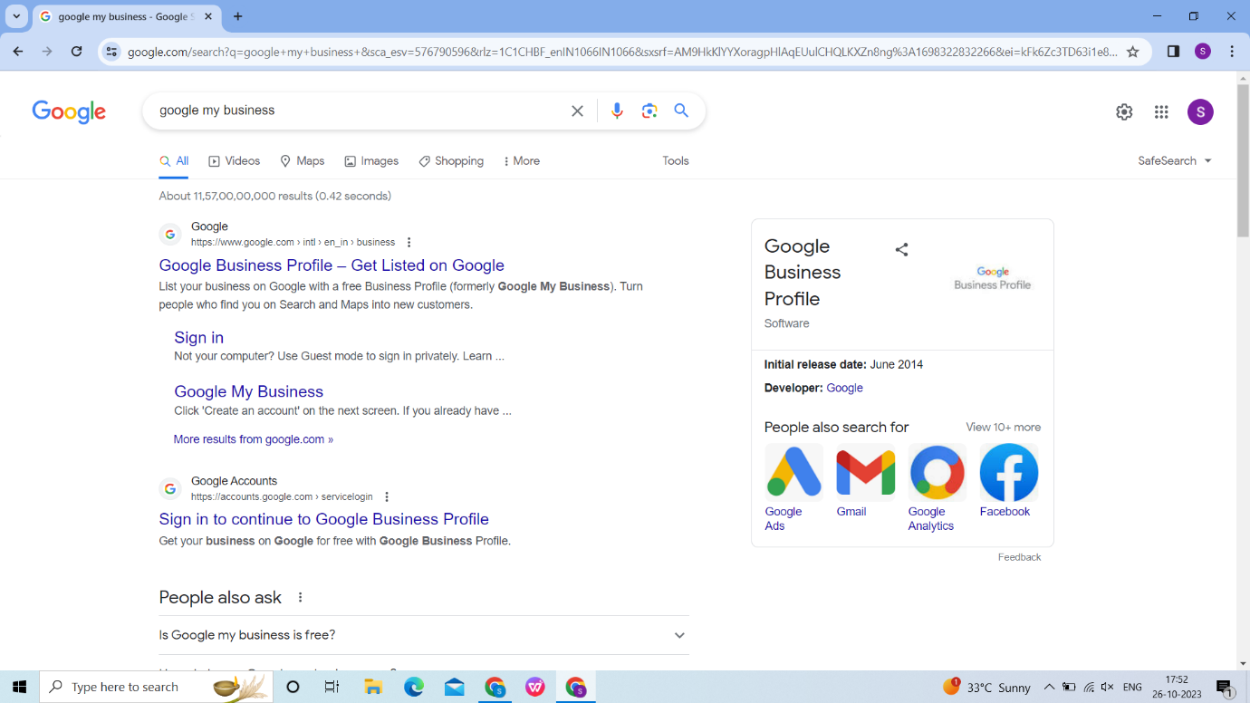

### Sign In

### C:\Users\DELL\Pictures\Screenshots\Screenshot (15).png

### Business Name

### C:\Users\DELL\Pictures\Screenshots\Screenshot (16).png

### Business Type

### C:\Users\DELL\Pictures\Screenshots\Screenshot (17).png

### Business Category

### C:\Users\DELL\Pictures\Screenshots\Screenshot (18).png

**Business Address**

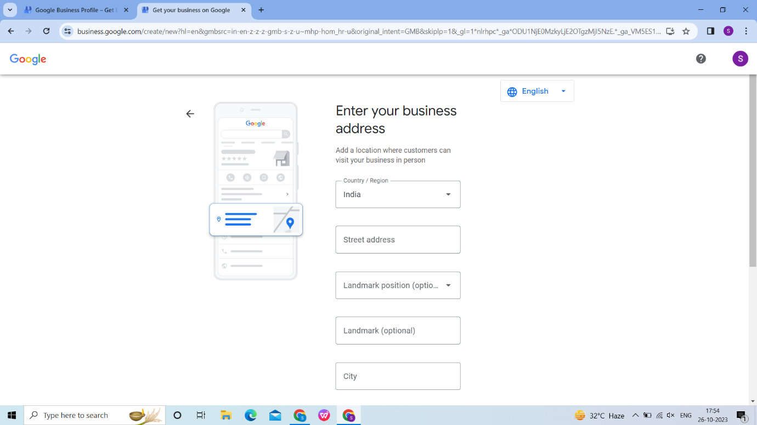

### Checking The Business

### C:\Users\DELL\Pictures\Screenshots\Screenshot (21).png

### Check The Location And Click Next

### C:\Users\DELL\Pictures\Screenshots\Screenshot (22).png

### Contact Details

### C:\Users\DELL\Pictures\Screenshots\Screenshot (23).png

### Click The Check Boxes If You Needed And Click Continue

### C:\Users\DELL\Pictures\Screenshots\Screenshot (24).png

### Verification

### C:\Users\DELL\Pictures\Screenshots\Screenshot (25).png

### Business Hours

### C:\Users\DELL\Pictures\Screenshots\Screenshot (27).png

### Adding Messing Feature

### C:\Users\DELL\Pictures\Screenshots\Screenshot (28).png

### Business Description

### C:\Users\DELL\Pictures\Screenshots\Screenshot (29).png

### Upload Photos

### C:\Users\DELL\Pictures\Screenshots\Screenshot (30).png

### Claim Your Business

### C:\Users\DELL\Pictures\Screenshots\Screenshot (31).png

### Click "Continue"

### C:\Users\DELL\Pictures\Screenshots\Screenshot (32).png

### Click "Edit Profile"

### C:\Users\DELL\Pictures\Screenshots\Screenshot (33).png

### Click "Read Reviews"

### C:\Users\DELL\Pictures\Screenshots\Screenshot (36).png

### Click "Performance"

### C:\Users\DELL\Pictures\Screenshots\Screenshot (34).png

### Click "Edit Products"

### C:\Users\DELL\Pictures\Screenshots\Screenshot (35).png